Definitions
Claim A record of the billing transaction for health care services provided. Every time a person with insurance visits a doctor, is admitted to a hospital, fills a prescription, or receives any other type of healthcare-related service, a claim is generated and sent to the insurance company. A single visit to a health provider might generate multiple claims for services (e.g. claim for the provider fee, facility fee, laboratory or imaging services, etc.). Insurers send these claims to DHIN after they are processed to incorporate into the Healthcare Claims Database. The lag time between date of service and date of submission to DHIN is typically about 2-3 months.
Visit Groups multiple claims that are related to the same healthcare “episode of care.” For example, an Emergency Department “visit” would contain the claims for all services that occurred at the emergency department for the issue being treated.
Institutional Claims Institutional billing, also known as hospital billing, refers to claims for healthcare services performed by institutions such as hospitals, nursing facilities, as well as inpatient and outpatient centers.
Facility claims are institutional claims that include services that occur in hospitals, skilled nursing facility, clinics or similar.
Professional claims Professional billing, also known as physician billing, is the billing of claims for healthcare services performed by a physician or other healthcare professionals, including inpatient and outpatient services. These are non-institutional claims that include services that occur in offices, retail/urgent care clinics, rehabilitation facilities or similar. Professional claims can take place in a hospital when rendered by a practitioner, for example an institutional claim for the use of an operating room may be accompanied by a professional claim for an anesthesiologist or surgeon.
Other service claims include home health, hospice, group homes, pharmacies and other unlisted facilities.
Care Setting Care setting describes the location where the service occurred. Examples include, acute inpatient hospital, office, intermediate care facility, skilled nursing facility, rehabilitation facility, home, residential, urgent care, laboratory, dialysis center and more. Care Settings are assigned to both institutional and professional claims.
Service Line Service line classifies claims into inpatient, outpatient, home health, provider, ambulance, independent labs, pharmacy and other. For example, this would distinguish a care setting of ‘hospital’ into inpatient vs. laboratory services. Please note that a service line of ‘provider’ includes office visits, which accounts for most claims.
Total Paid Amount The amount paid by the insurer to the health care provider (also known as the allowed amount) plus the portion paid by the member, which includes coinsurance, copay and deductible amounts.
Distinct Individual Unique people being counted. Each person is only counted once, even if they were under multiple plans in one year.

Report Navigation

The DHIN HCCD public facing reports are built in the business intelligence/visualization tool Tableau. See below for key features of interacting with and understanding these reports -
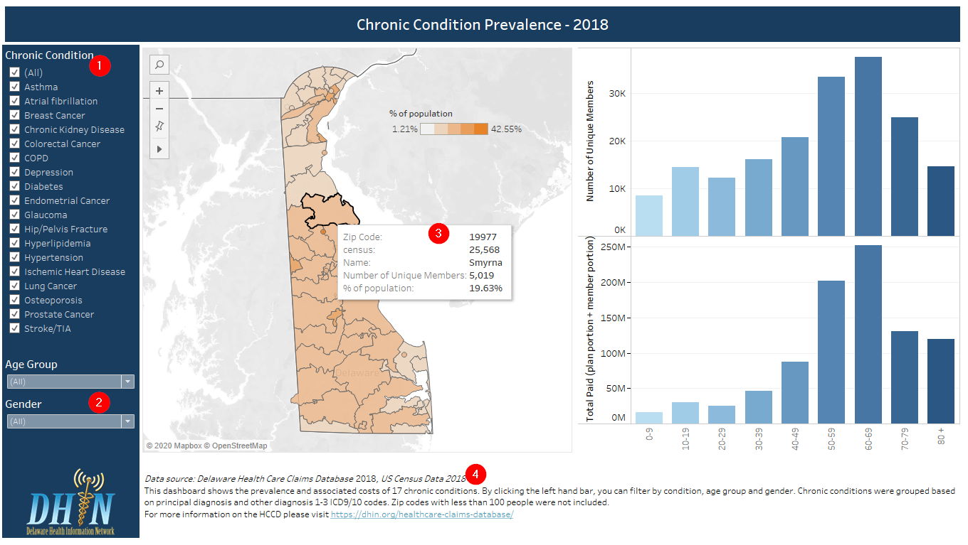
(1) & (2) Filters The left-hand bar on each report has filters you can use to change the results of the report. Some filters, like (1), are listed and some, like (2) are drop down. Filters change based on the content of the report, examples include age group, insurance type, gender and year.
(3) Hover text When you hover or move your cursor over a bar or section of a map, text will appear that shows specific details for that particular data point (including full names where text is abbreviated in chart labels).
(4) Notes This text contains additional information on the report as well as the data sources used.

